
Company
Logotype

Cone Beam Computed Tomography- Report



Porur Dental X-rays & CBCT

Patient Name : Mrs. Mahalakshmi | Date of Report : 17.07.2024
Age/ Gender : 43 years/ Female | Region of Interest : CBCT Sectional Mandible
Referring doctor: Meenakshi Ammal Dental College | Indication : Implant assessment
Clinical Notes: Nil
PATIENT INFORMATION

CBCT- Sectional Mandible provided
CBCT – IMAGE DETAILS

RADIOGRAPHIC INTERPRETATION

- Complete loss of crown and root structure in relation to 46.
- The alveolar bone in relation to 46 is present with normal trabecular pattern.
- Presence of hyperdense restoration in relation to crown of 47, 48 is evident..

IMPLANT ASSESSMENT

 | 46 region
Sub-Crestal (in mm) | 8.28
Mid- Crestal (in mm) | 11.66
Distance between alveolar ridge and the inferior alveolar nerve canal (in mm) | 15.86
Distance between alveolar ridge and the inferior border of mandible (in mm) | 24.02
Distance between distal portion of 45 and mesial portion of 47  (in mm) | 8.13 (at the level of occlusal plane)  9.66 (at the level of CEJ)

RADIOGRAPHIC IMPRESSION

- Partially edentulous region: 46.
- Restored teeth: 47, 48.

Kindly correlate with clinical findings


IMAGES FOR REFERENCE

RECONSTRUCTED PANORAMIC VIEW
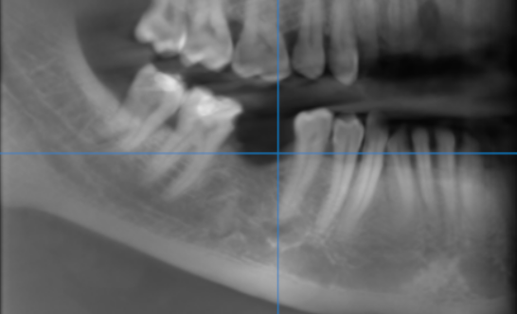

3-DIMENSIONAL VIEW

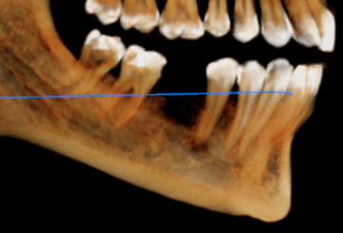

CROSS SECTIONAL VIEW

46 region | 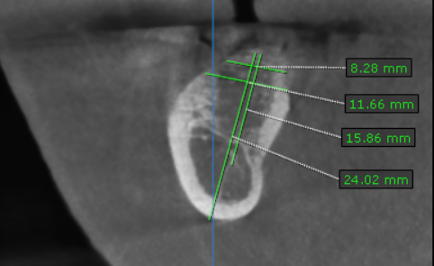
46 region | 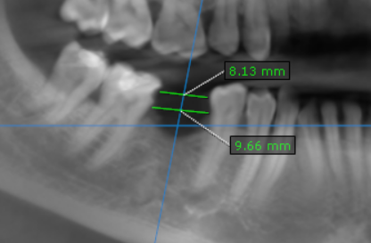

**** End of report ****

